- [1.5+4+2] Draw the state diagram for the given circuit.

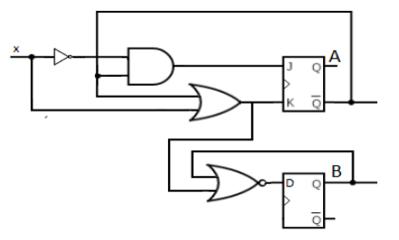

- [3+1+1+2.5] Implement the following counter using T FF:
Green->Orange->Yellow->Red->Yellow->Orange->Yellow->Green

